1.0 PURPOSE

The purpose of this Advisory Circular (AC) is to provide guidance to service providers on how to manage change in an SMS environment. This AC also provides the necessary information to enable the service providers to establish a formal process that guides the effective management of changes as they occur in an operational environment

2.0 REFERENCE

The Civil Aviation (Safety Management) Regulations, as amended

3.0 BACKGROUND

Aviation service providers experience change due to a number of factors including, but not limited to:

a. organizational expansion or contraction;
b. changes to internal systems, processes or procedures that support delivery of the products and services; and
c. changes to the organization’s operating environment.

Changes may be external to the organization, or internal. Examples of external changes include changes in safety and or security regulatory requirements, and reorganization of operating air navigation procedures. Examples of internal changes include management changes, new equipment and procedures.

Hazards may inadvertently be introduced into an operation whenever changes occur. Safety management practices require that hazards that are a by-product of change be systematically and proactively identified and strategies to manage the associated safety risks developed, implemented and subsequently evaluated.

Change may also affect the appropriateness or effectiveness of existing safety risk mitigation strategies. Such existing safety risk mitigation strategies, therefore, require periodic review to ensure they remain appropriate and effective. New hazards introduced into the system by operational changes should be identified so as to enable the assessment and control of any related safety risks.

Safety reviews, can be valuable sources of information to support decision-making processes and effective management of change.

4.0 THE MANAGEMENT OF CHANGE

The current Civil Aviation (Safety Management) Regulations requires that a service provider shall, as part of its SMS safety assurance activities, develop and maintain a formal process for the management of change.

The formal process developed for the management of change should:

a. Identify changes within the organization which may affect established processes and services;

b. Identify new hazards and assess associated safety risks that may be introduced into the system in the process of implementing changes; and

c. Review or modify safety risk controls that are no longer needed due to changes in the operational environment.

The organization’s management of change process should take into account the following three considerations:

(i) Criticality.

Criticality assessments determine the systems, equipment or activities that are essential to the safe operation of aircraft. While criticality is normally assessed during the system design process, it is also relevant during a situation of change. Systems, equipment and activities that have higher safety criticality should be reviewed following change to make sure that corrective actions can be taken to control potentially emerging safety risks.

(ii) Stability of systems and operational environments.

Changes may be planned and under the direct control of the organization. Such changes include organizational growth or contraction, the expansion of products or services delivered, or the introduction of new technologies. Unplanned changes may include those related to economic cycles, labour unrest, as well as changes to the political, regulatory or operating environments.

(iii) Past performance.

Past performance of critical systems and trend analyses in the safety assurance process should be employed to anticipate and monitor safety performance under situations of change. The monitoring of past performance will also assure the effectiveness of corrective actions taken to address safety deficiencies identified as a result of audits, evaluations, investigations or reports.

As systems evolve, incremental changes can accumulate, requiring amendments to the initial system description. Therefore, change management necessitates periodic reviews of the system description and the baseline hazard analysis to determine their continued validity.

5.0 SAFETY RISK MANAGEMENT

Safety risk management processes described in the Advisory Circular TCAA-AC-GEN015A must be followed whenever changes occur in the operational environment. The identified safety risks shall be assessed and their effects appropriately mitigated to ensure safety risk controls remain appropriate and effective.

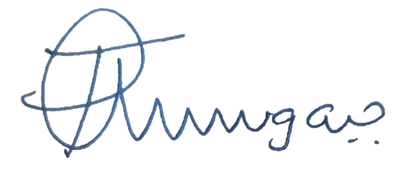

____________________
Director Safety Regulation

